Aperiodic Tessellation
# Source: AI Source: Provided by: [Data Path: Persons Table -> ID Column: 1, Name_En Column: Motasem Essam] -> From: [ChatGPT] on [7/25/2026]
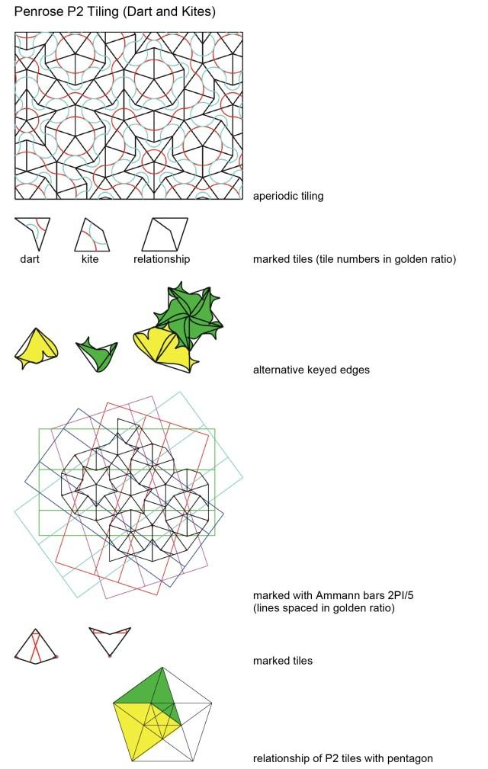
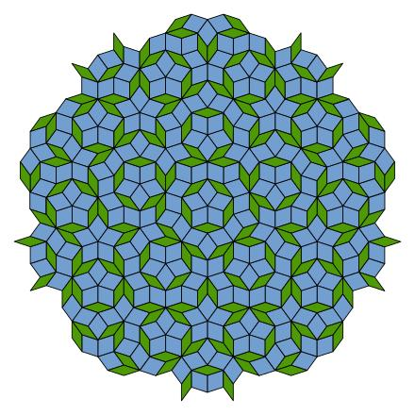
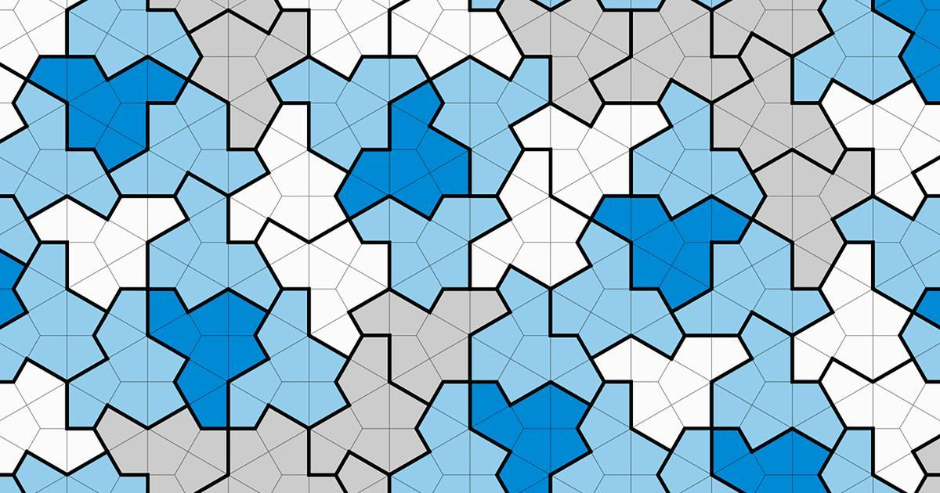
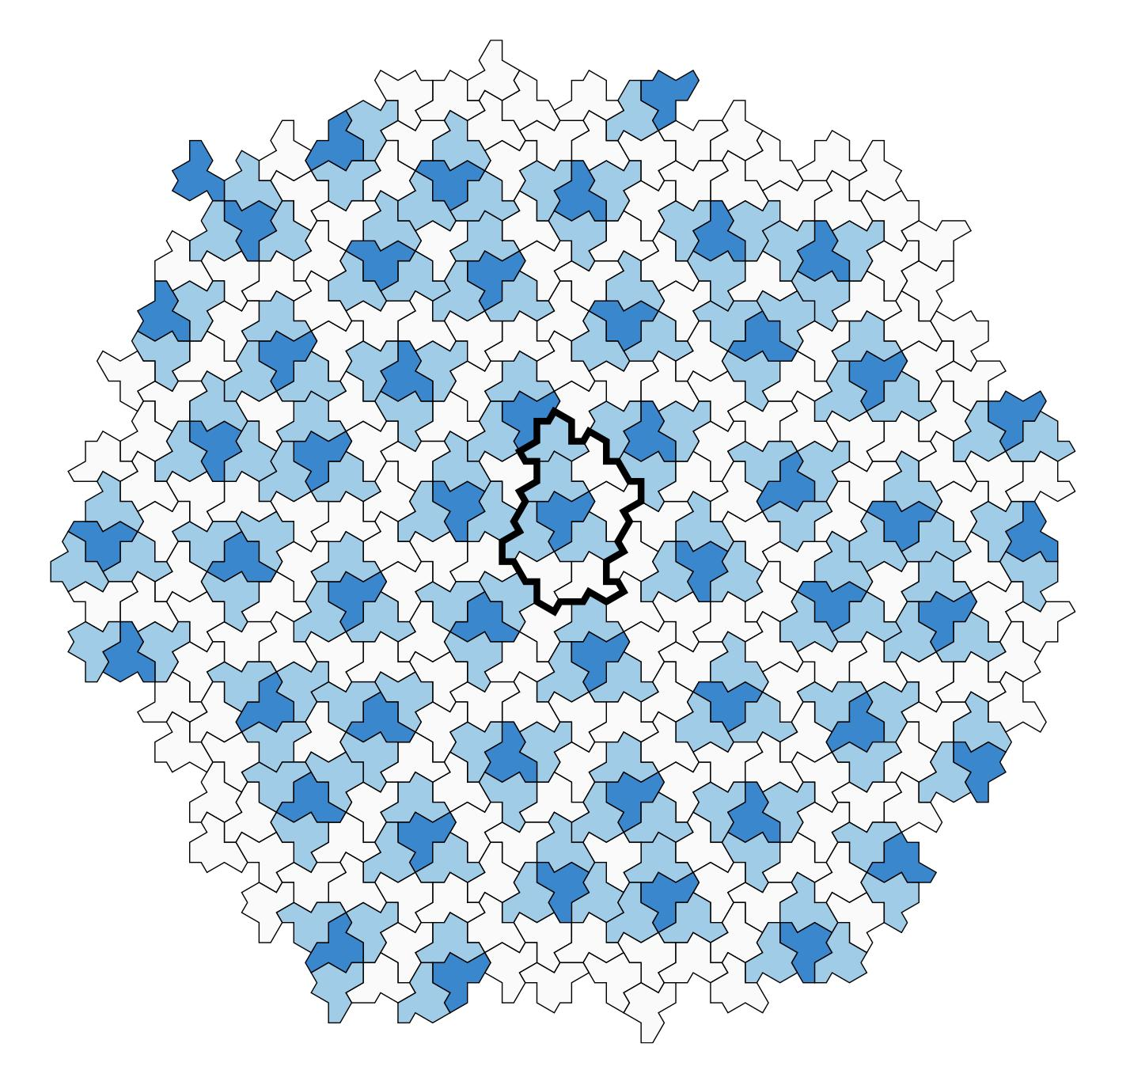
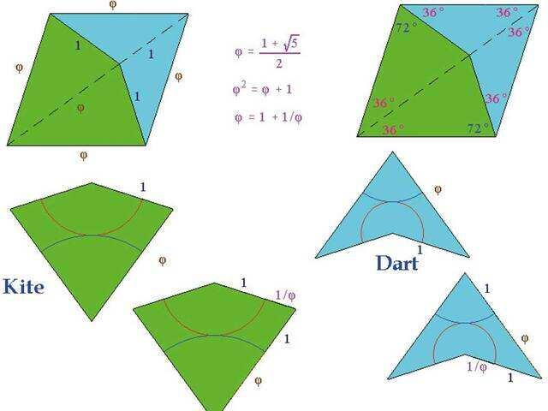
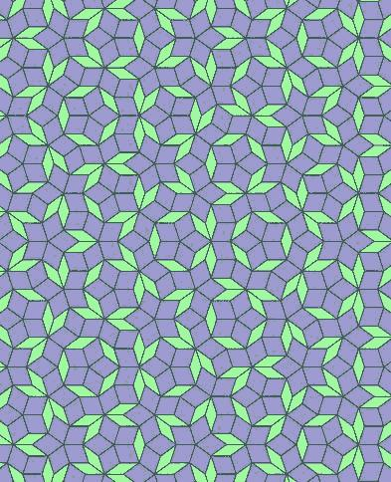

Definition
# Source: AI Source: Provided by: [Data Path: Persons Table -> ID Column: 1, Name_En Column: Motasem Essam] -> From: [ChatGPT] on [7/25/2026]
An Aperiodic Tessellation is a tessellation of the plane that is non-periodic in a strong sense: it has no translational repetition, and it does not contain arbitrarily large periodic patches.
In particular:
Every aperiodic tessellation is non-periodic, but not every non-periodic tessellation is aperiodic. (MathWorld)
This distinction is important for your classification.

Classification Position
# Source: AI Source: Provided by: [Data Path: Persons Table -> ID Column: 1, Name_En Column: Motasem Essam] -> From: [ChatGPT] on [7/25/2026]
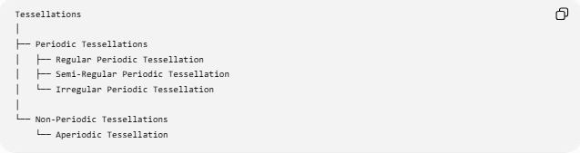
Tessellations
│
├── Periodic Tessellations
│ ├── Regular Periodic Tessellation
│ ├── Semi-Regular Periodic Tessellation
│ └── Irregular Periodic Tessellation
│
└── Non-Periodic Tessellations
└── Aperiodic Tessellation
However, aperiodic is technically a stronger property than simply "non-periodic."
A more mathematically precise relationship is:
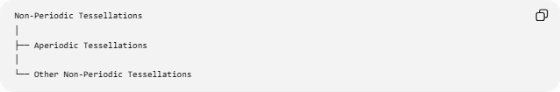
Non-Periodic Tessellations
│
├── Aperiodic Tessellations
│
└── Other Non-Periodic Tessellations

1. Non-Periodic vs Aperiodic
# Source: AI Source: Provided by: [Data Path: Persons Table -> ID Column: 1, Name_En Column: Motasem Essam] -> From: [ChatGPT] on [7/25/2026]
This is the most important distinction.
Non-periodic tessellation
A tessellation is non-periodic if there is no nonzero translation that maps the entire tessellation onto itself. (MathWorld)
Symbolically:
$$\boxed{\text{No nonzero translational symmetry}}$$
But a non-periodic tessellation can still contain arbitrarily large regions that look periodic.
Aperiodic tessellation
An aperiodic tessellation satisfies the stronger condition that:
$$\boxed{\text{No arbitrarily large periodic patches occur}}$$
Thus:
$$\boxed{\text{Aperiodic}⊂\text{Non-Periodic}}$$
but:
$$\boxed{\text{Non-Periodic}⊄\text{Aperiodic}}$$
(MathWorld)

2. Aperiodic Does Not Mean Random
# Source: AI Source: Provided by: [Data Path: Persons Table -> ID Column: 1, Name_En Column: Motasem Essam] -> From: [ChatGPT] on [7/25/2026]
An aperiodic tessellation can have very strong mathematical order.
It can have:
- Repeating local rules
- Hierarchical structure
- Long-range order
- Strict geometric constraints
- Substitution/inflation rules
- Rotational symmetry
What it lacks is translational periodicity.
For example, Penrose tilings have highly organized structure despite never becoming translationally periodic. They are also associated with quasicrystalline order. (MathWorld)
So:
$$\boxed{\text{Aperiodic}≠\text{Random}}$$

3. Penrose Tessellation
# Source: AI Source: Provided by: [Data Path: Persons Table -> ID Column: 1, Name_En Column: Motasem Essam] -> From: [ChatGPT] on [7/25/2026]
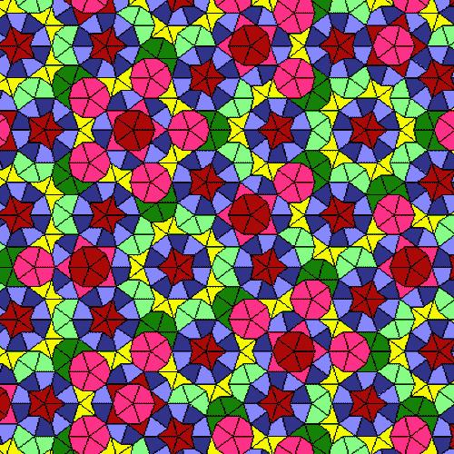
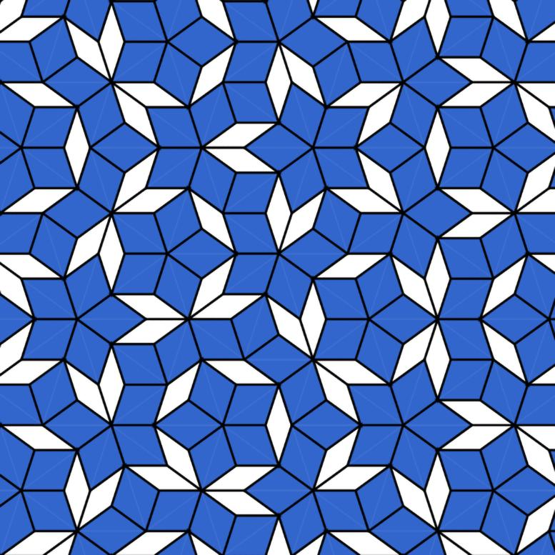
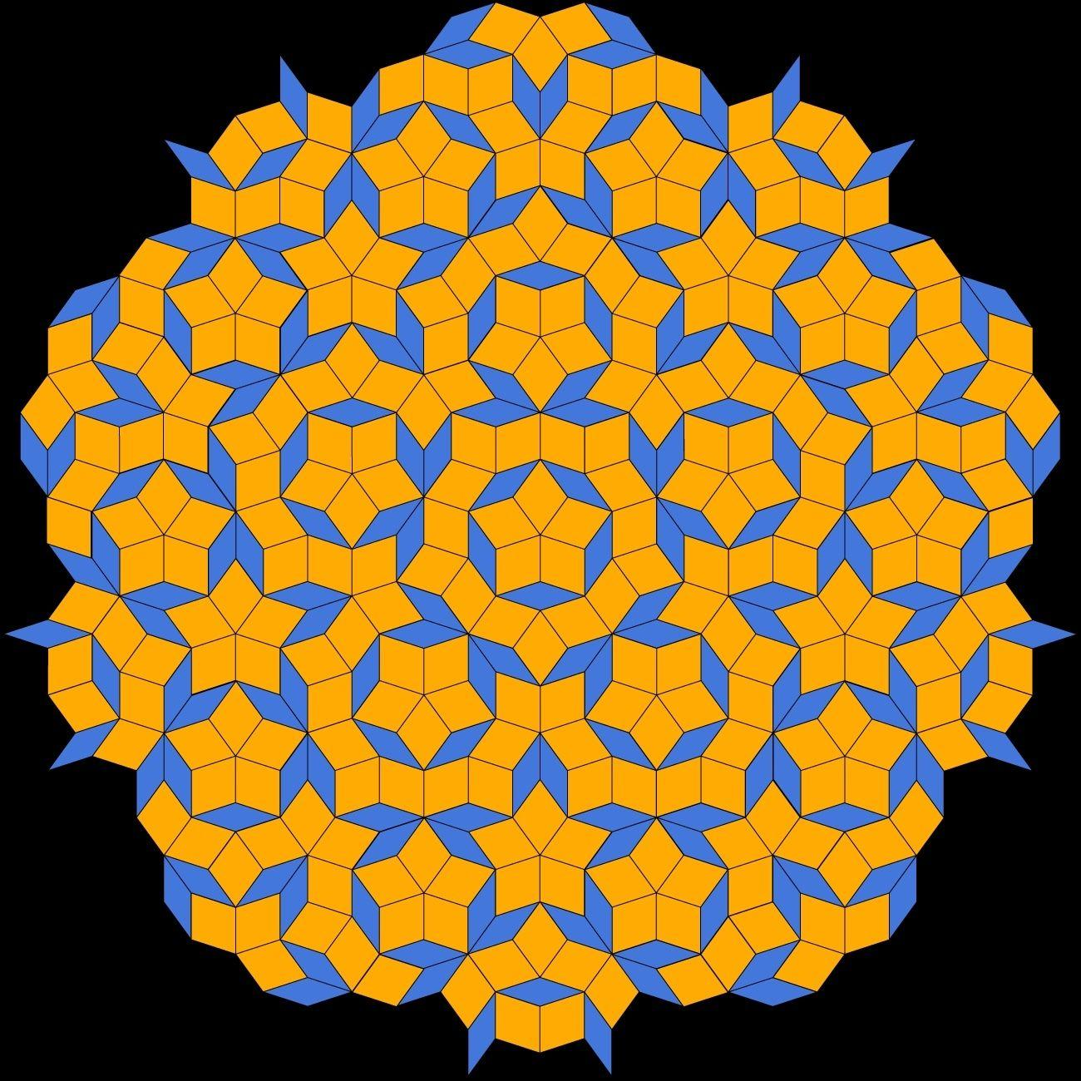
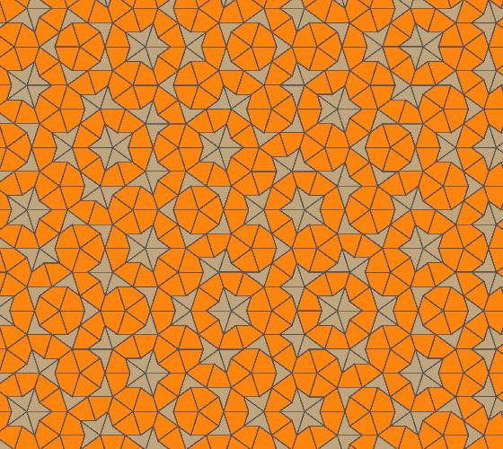
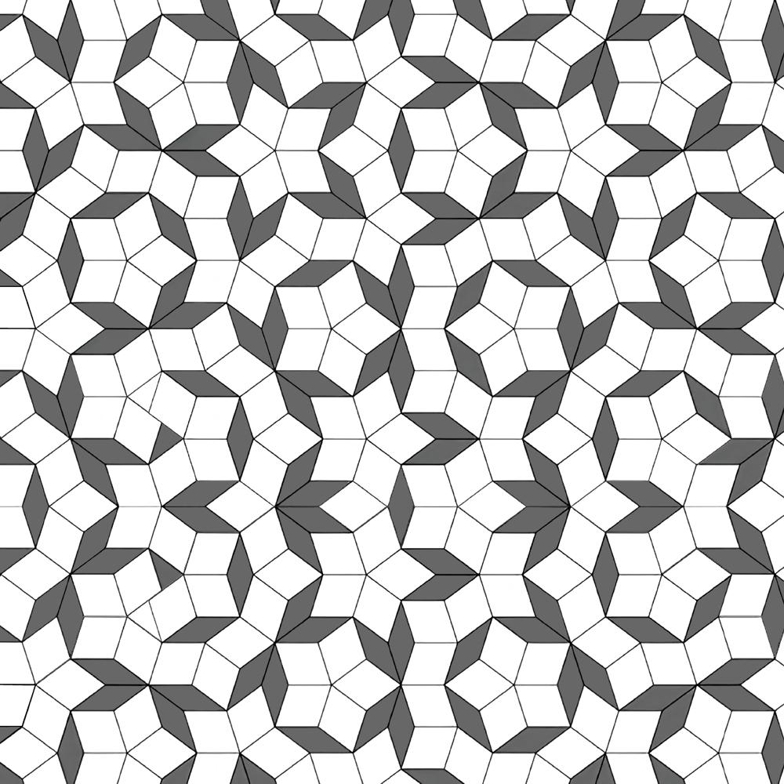
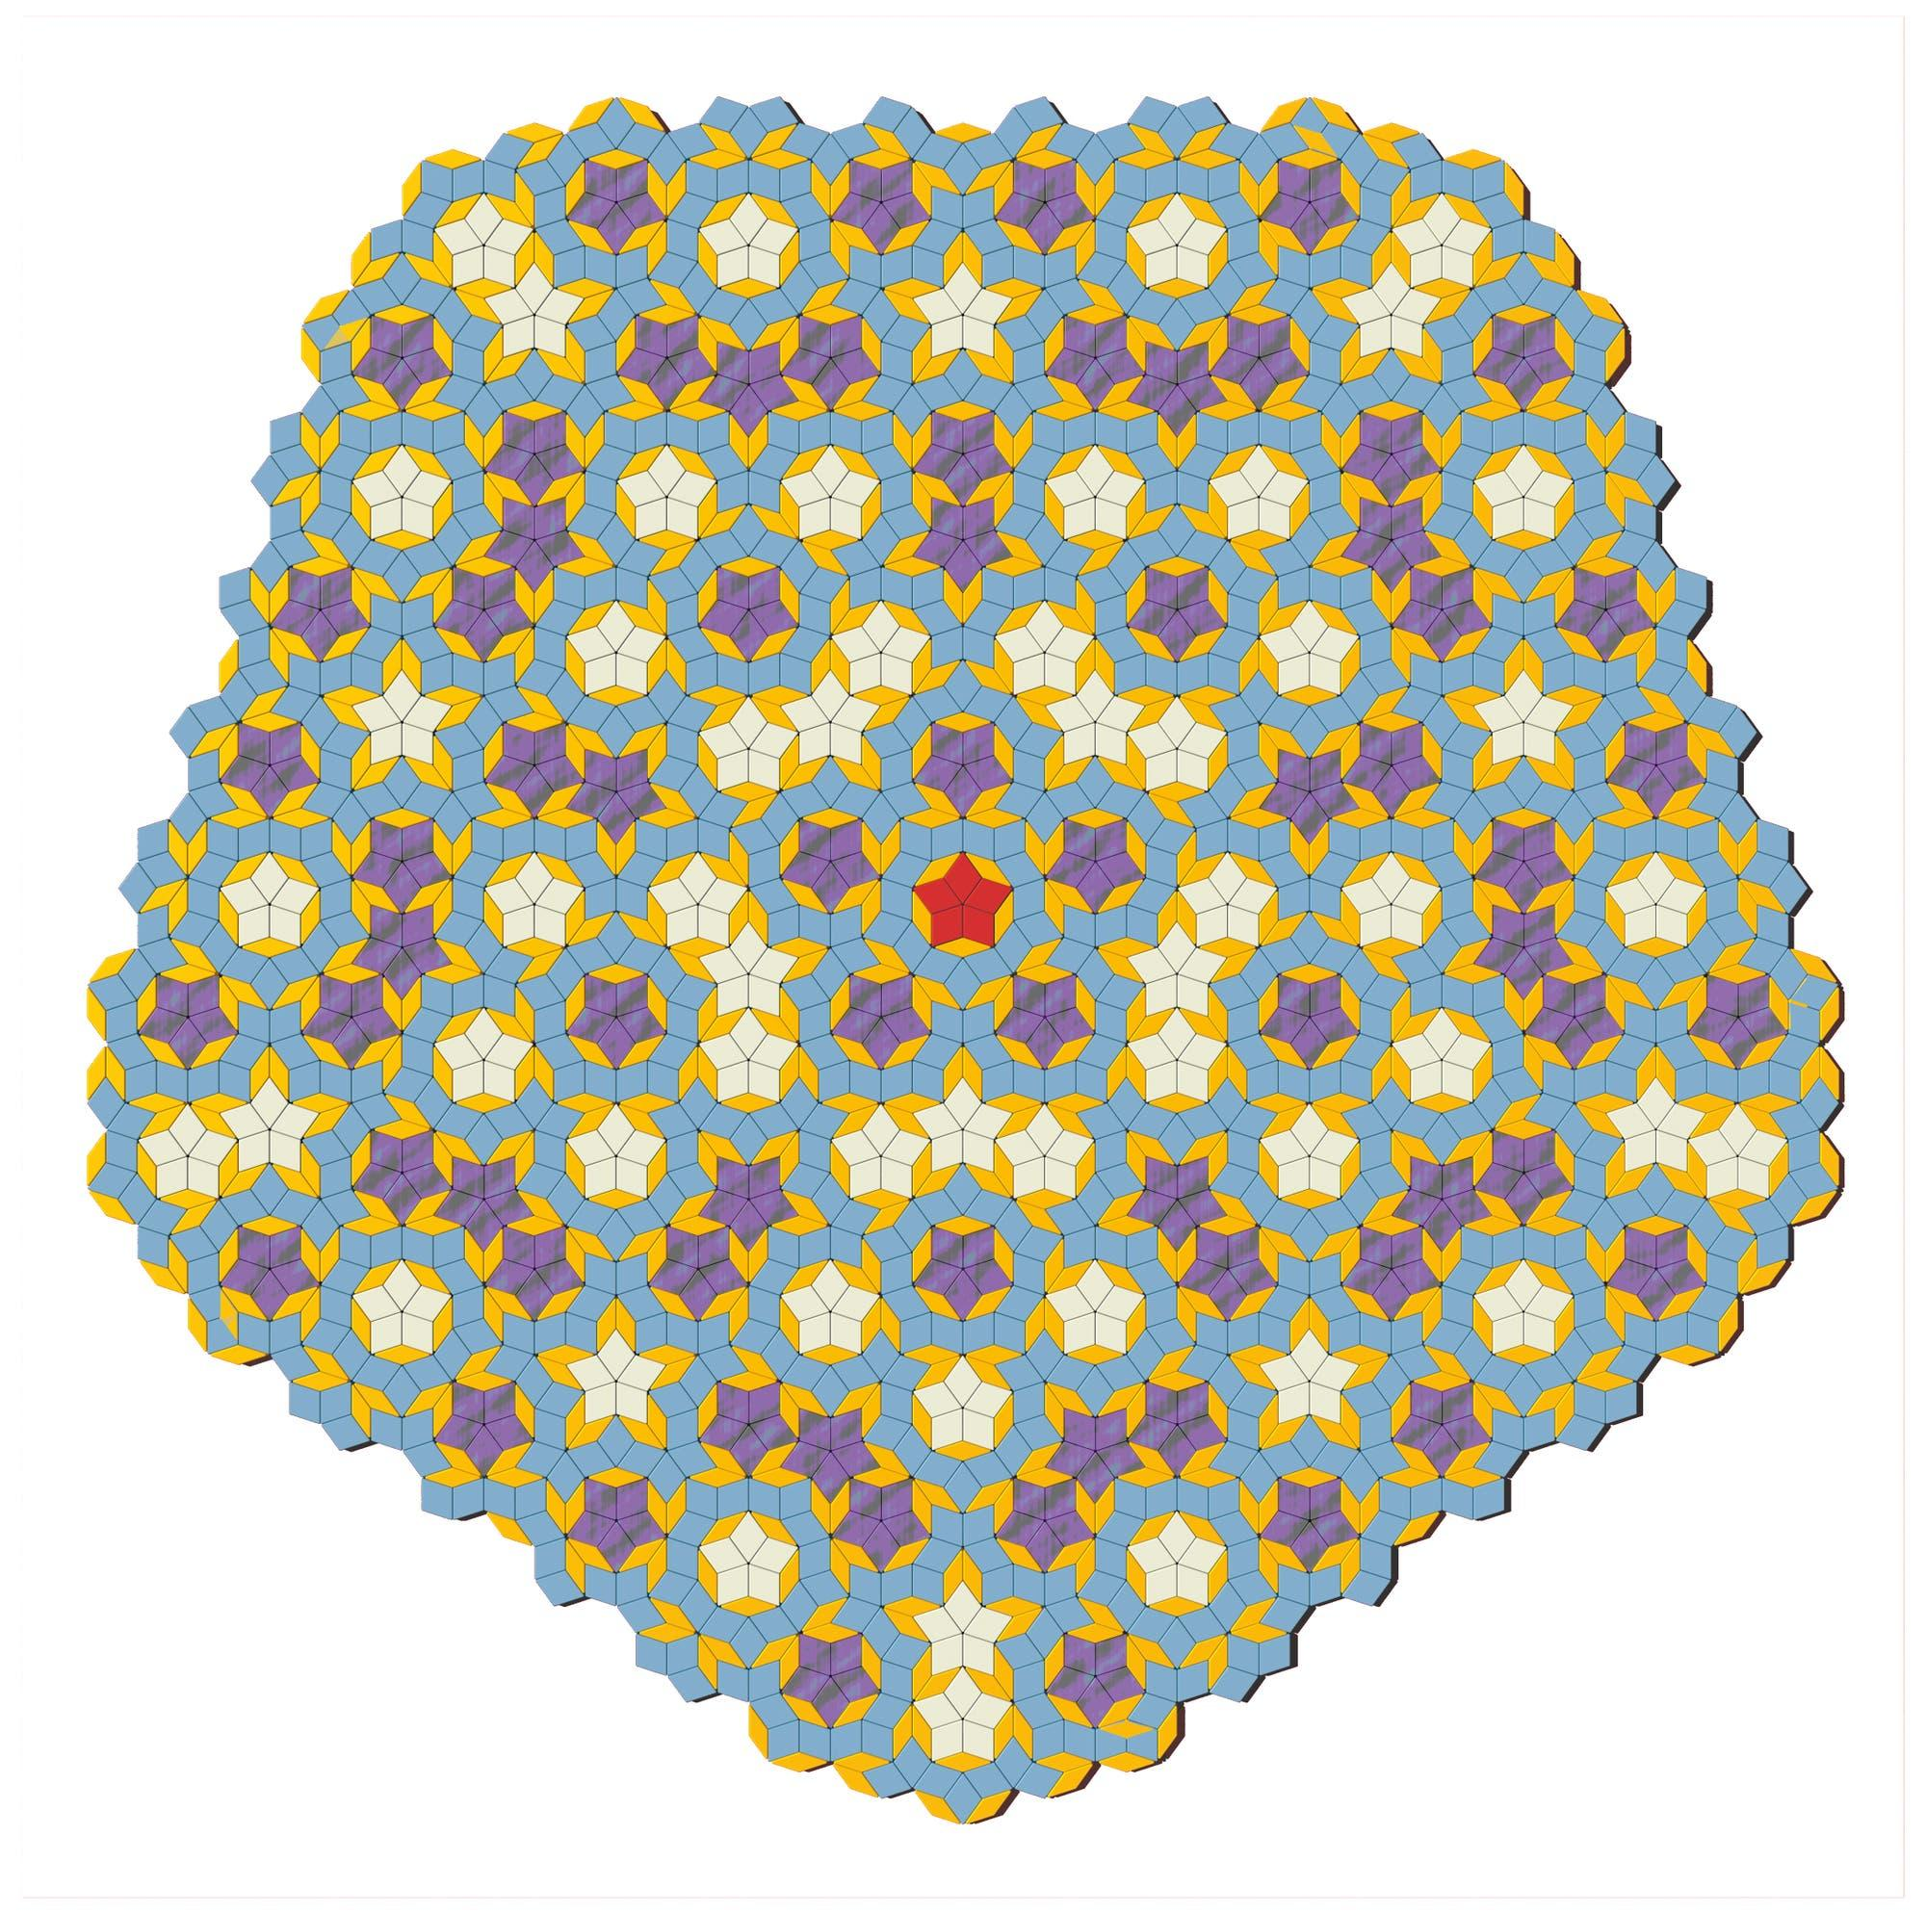
The Penrose tessellation is the classic example of an aperiodic tessellation.
One well-known Penrose system uses two tiles:
- Kite
- Dart
With appropriate matching rules, these two tiles can tile the plane only aperiodically. (MathWorld)
The resulting pattern:
- Covers the plane.
- Has no translational period.
- Can contain fivefold rotational structures.
- Has long-range mathematical order.
- Never settles into a repeating unit.

4. Aperiodic Monotile
# Source: AI Source: Provided by: [Data Path: Persons Table -> ID Column: 1, Name_En Column: Motasem Essam] -> From: [ChatGPT] on [7/25/2026]
A particularly important development is the aperiodic monotile.
A monotile is a single tile shape that can tile the plane.
An aperiodic monotile is a single tile that can tile the plane only aperiodically. (MathWorld)
In 2023, David Smith, Joseph Samuel Myers, Craig S. Kaplan, and Chaim Goodman-Strauss presented the Hat polykite, solving the long-standing problem of finding an aperiodic monotile. (MathWorld)
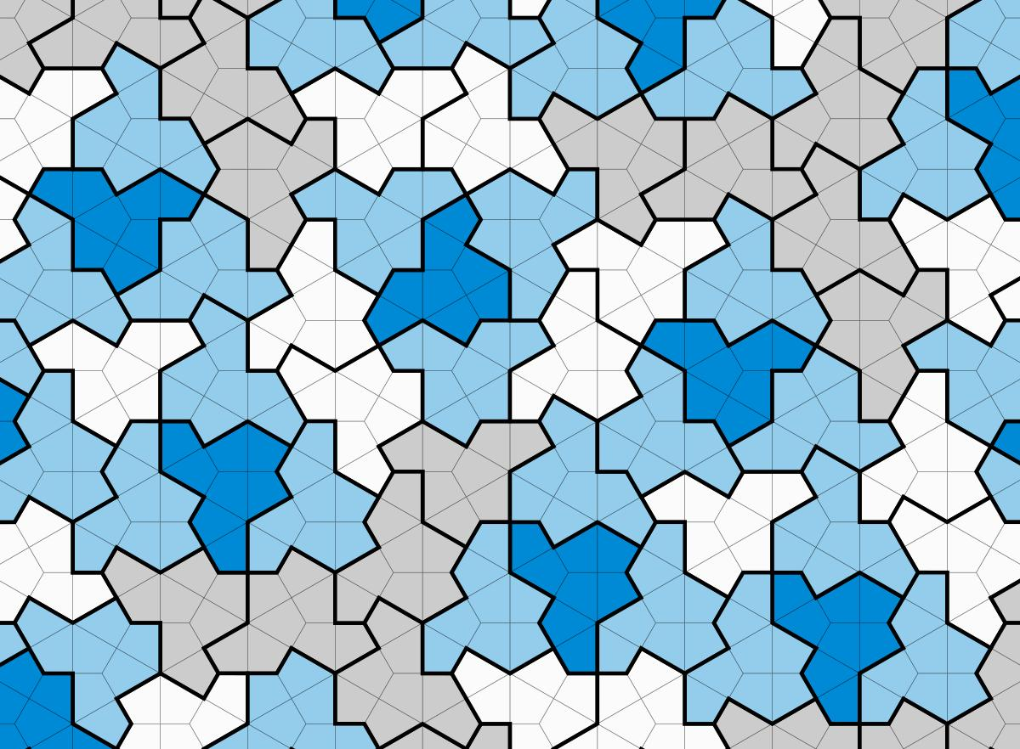
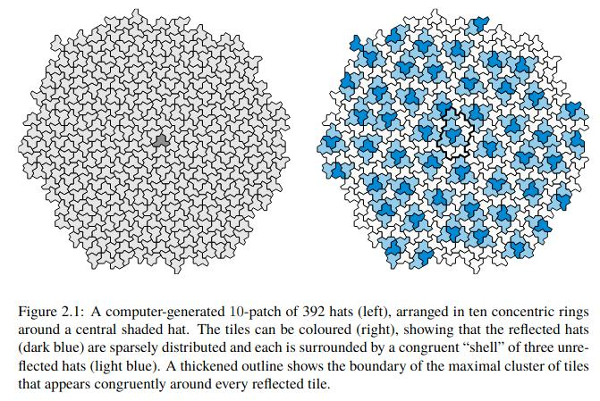
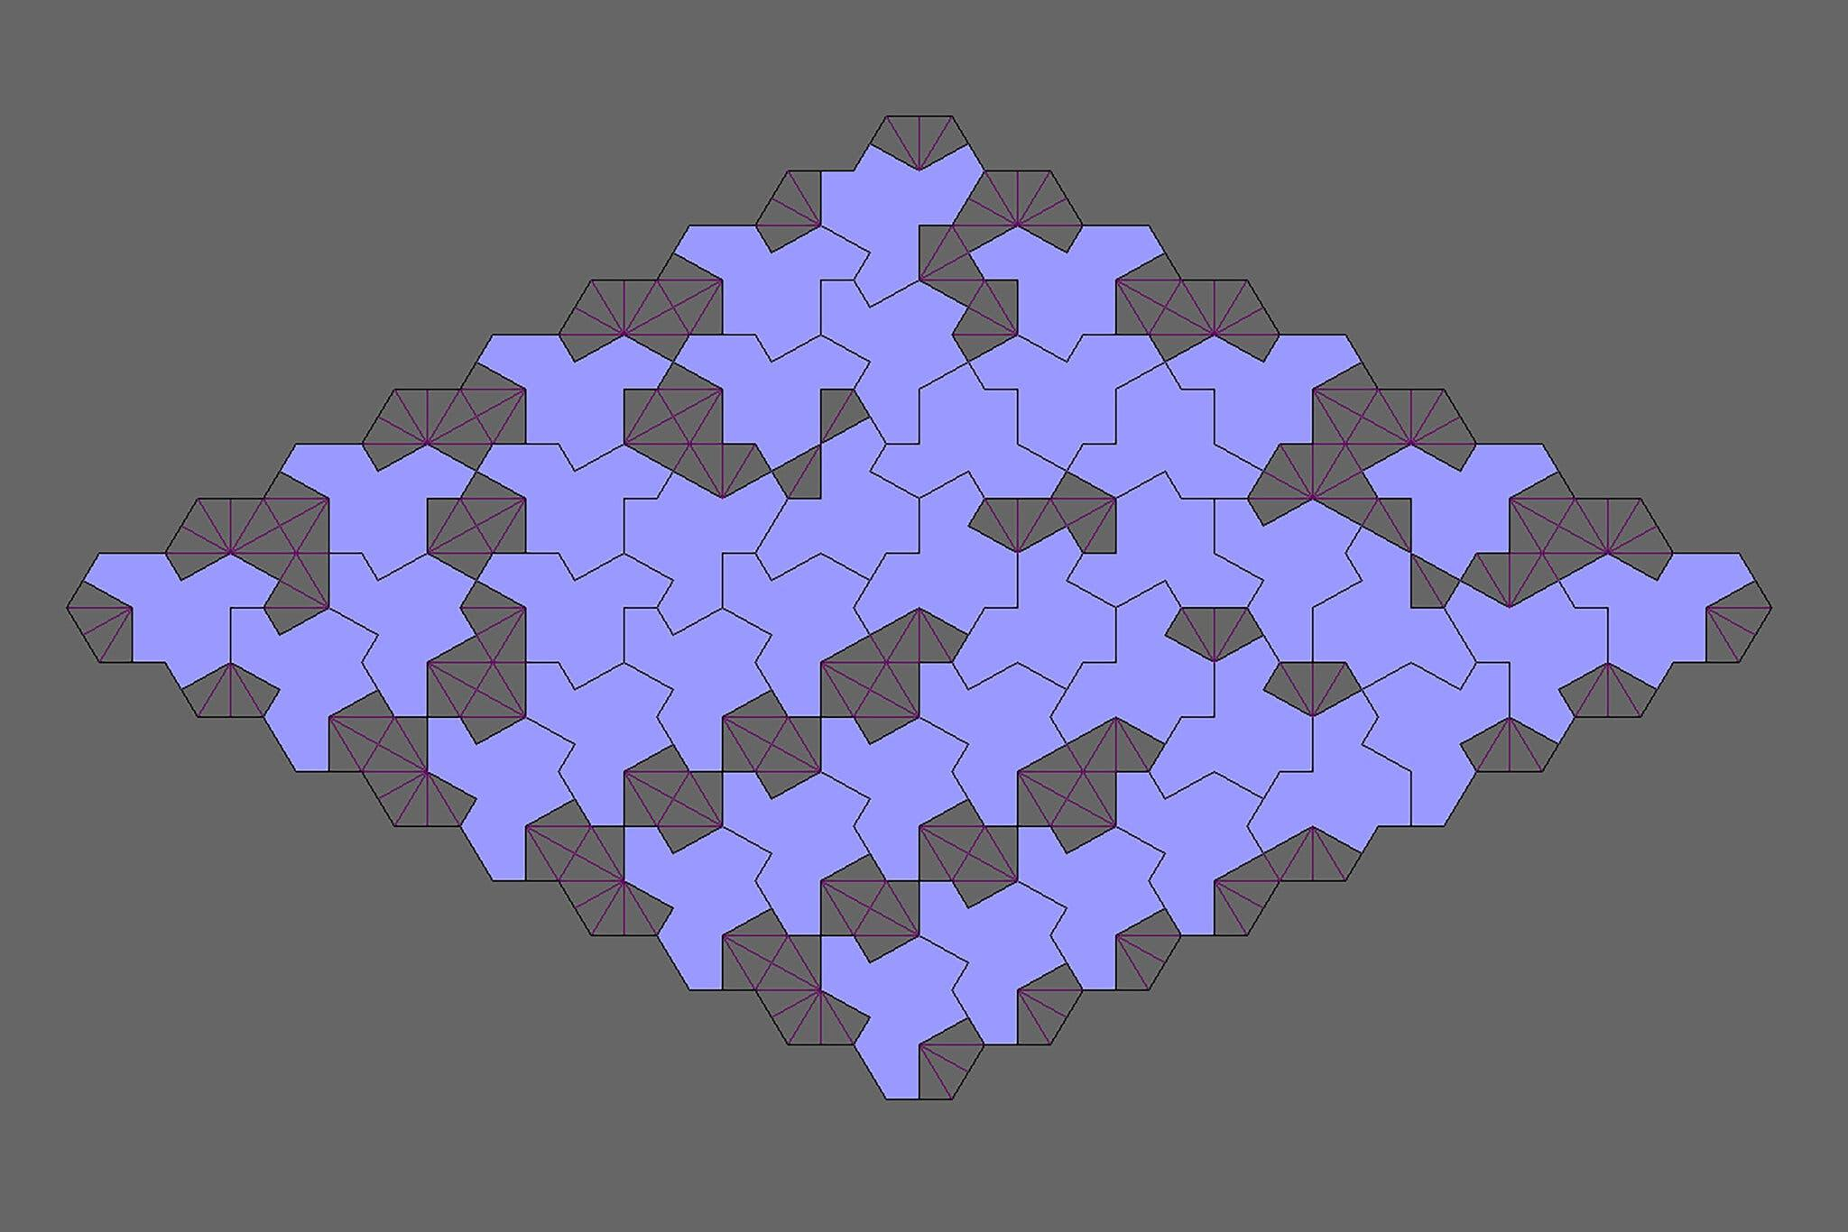
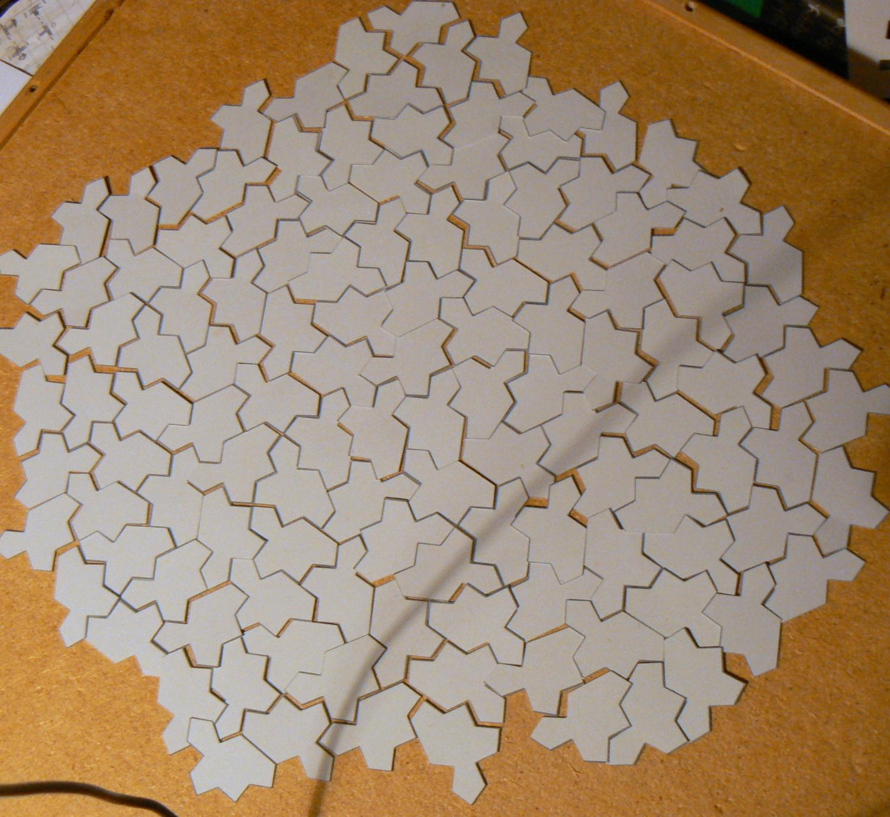
This gives an important distinction:
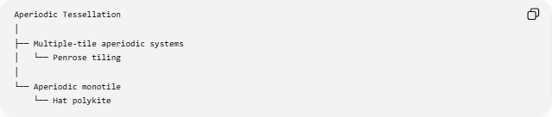
Aperiodic Tessellation
│
├── Multiple-tile aperiodic systems
│ └── Penrose tiling
│
└── Aperiodic monotile
└── Hat polykite

5. Penrose vs Hat
# Source: AI Source: Provided by: [Data Path: Persons Table -> ID Column: 1, Name_En Column: Motasem Essam] -> From: [ChatGPT] on [7/25/2026]
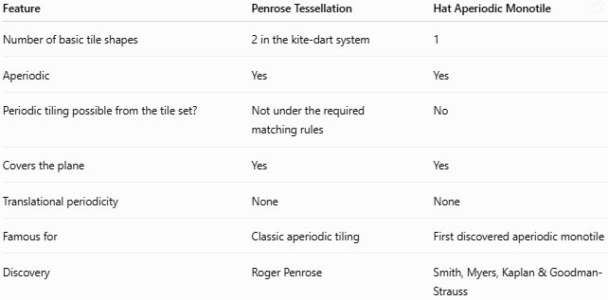
Feature | Penrose Tessellation | Hat Aperiodic Monotile
Number of basic tile shapes | 2 in the kite-dart system | 1
Aperiodic | Yes | Yes
Periodic tiling possible from the tile set? | Not under the required matching rules | No
Covers the plane | Yes | Yes
Translational periodicity | None | None
Famous for | Classic aperiodic tiling | First discovered aperiodic monotile
Discovery | Roger Penrose | Smith, Myers, Kaplan & Goodman-Strauss
The Hat is therefore a particularly important example because one tile shape alone is sufficient to force aperiodicity. (MathWorld)

6. Aperiodic Tessellation vs Periodic Tessellation
# Source: AI Source: Provided by: [Data Path: Persons Table -> ID Column: 1, Name_En Column: Motasem Essam] -> From: [ChatGPT] on [7/25/2026]
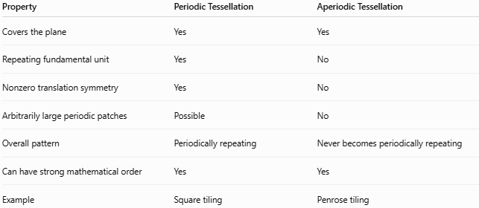
Property | Periodic Tessellation | Aperiodic Tessellation
Covers the plane | Yes | Yes
Repeating fundamental unit | Yes | No
Nonzero translation symmetry | Yes | No
Arbitrarily large periodic patches | Possible | No
Overall pattern | Periodically repeating | Never becomes periodically repeating
Can have strong mathematical order | Yes | Yes
Example | Square tiling | Penrose tiling

7. Aperiodic Tessellation vs Ordinary Non-Periodic Tessellation
# Source: AI Source: Provided by: [Data Path: Persons Table -> ID Column: 1, Name_En Column: Motasem Essam] -> From: [ChatGPT] on [7/25/2026]
This distinction should be included in your knowledge base:
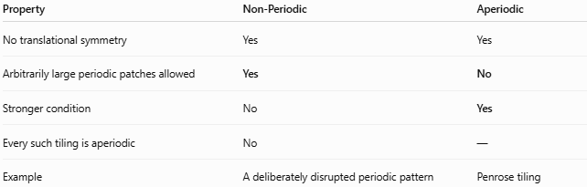
Property | Non-Periodic | Aperiodic
No translational symmetry | Yes | Yes
Arbitrarily large periodic patches allowed | Yes | No
Stronger condition | No | Yes
Every such tiling is aperiodic | No | —
Example | A deliberately disrupted periodic pattern | Penrose tiling
For example, imagine a normally repeating square pattern and introduce a disturbance that prevents the whole infinite arrangement from having translational symmetry. It is non-periodic, but that alone does not make it a mathematically aperiodic tiling, because large periodic regions may still exist.

8. Important Property: Local Order Without Global Periodicity
# Source: AI Source: Provided by: [Data Path: Persons Table -> ID Column: 1, Name_En Column: Motasem Essam] -> From: [ChatGPT] on [7/25/2026]
Aperiodic tessellations are especially interesting because they can have:
$$\text{Local Order} + \text{Long-Range Order} + \text{No Translational Periodicity}$$
This is one reason Penrose tilings are important in the study of mathematical tilings and quasicrystalline structures. (MathWorld)

Key Characteristics
# Source: AI Source: Provided by: [Data Path: Persons Table -> ID Column: 1, Name_En Column: Motasem Essam] -> From: [ChatGPT] on [7/25/2026]
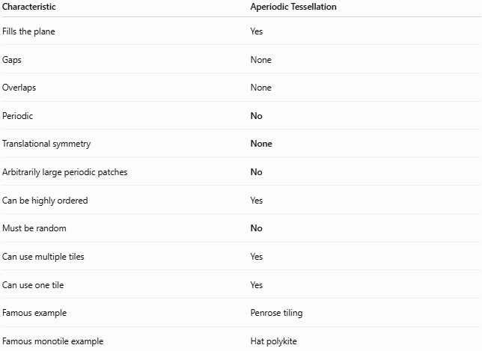
Characteristic | Aperiodic Tessellation
Fills the plane | Yes
Gaps | None
Overlaps | None
Periodic | No
Translational symmetry | None
Arbitrarily large periodic patches | No
Can be highly ordered | Yes
Must be random | No
Can use multiple tiles | Yes
Can use one tile | Yes
Famous example | Penrose tiling
Famous monotile example | Hat polykite

Important Terminology
# Source: AI Source: Provided by: [Data Path: Persons Table -> ID Column: 1, Name_En Column: Motasem Essam] -> From: [ChatGPT] on [7/25/2026]
There are three related terms:
Periodic
$$\boxed{\text{Repeats under a nonzero translation}}$$
Non-Periodic
$$\boxed{\text{Does not repeat under any nonzero translation}}$$
Aperiodic
$$\boxed{\text{Non-periodic + no arbitrarily large periodic patches}}$$
Therefore:
$$\boxed{\text{Aperiodic}⊂\text{Non-Periodic}}$$
This is the most important relationship to preserve in your taxonomy. (MathWorld)

Conclusion
# Source: AI Source: Provided by: [Data Path: Persons Table -> ID Column: 1, Name_En Column: Motasem Essam] -> From: [ChatGPT] on [7/25/2026]
An Aperiodic Tessellation is a highly structured tessellation that never becomes translationally periodic, even on arbitrarily large scales.
The classic example is the Penrose tessellation, while the Hat polykite provides the landmark example of an aperiodic monotile. (MathWorld)
For your knowledge-base classification:
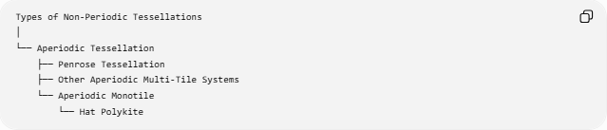
Types of Non-Periodic Tessellations
│
└── Aperiodic Tessellation
├── Penrose Tessellation
├── Other Aperiodic Multi-Tile Systems
└── Aperiodic Monotile
└── Hat Polykite
Key idea: an aperiodic tessellation is not simply a messy or random tessellation; it is a mathematically ordered tessellation that specifically prevents translational periodicity.

